Control Systems Lab

Lab 2 In-Class Exercise

Part 1: Identifying transfer function parameters from step response

- Motor ID: The DC motor system and Multimeter are labeled with a number. Please make note of them in Gradescope.

- Step Response Data: Obtain the step response data for the motor by simply running ‘M2V5_Motor_Step_Response_CSL.slx’ on the motor system. You do not have to modify the file at all - just open, examine the code so you know what experiment it is performing, run the code, and stop it after it has collected several steps. Save the data to a .mat file and upload the .mat file to Gradescope.

- Step Response Plot: Plot the data for only one single step that goes from one NON-ZERO steady state speed to another steady state speed. The plot should clearly show one and ONLY one step including the transient portion of the response: (use the xlim, ylim commands or the graph zoom tool introduced in Lab 1.5)
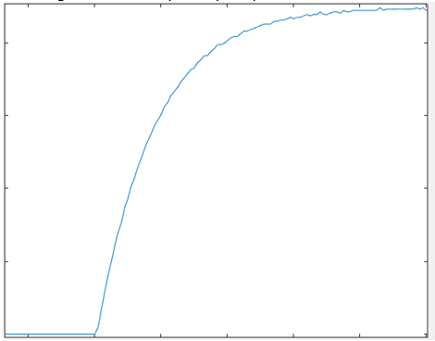
This is the step response you will determine $K$ and $τ$ from in the lab submission. Upload a screenshot of a properly annotated plot in Gradescope (Upload a .png. NOT the .fig file and NOT a .pdf file – make sure you can see the actual plot in gradescope).

Part 2: Identifying ODE parameters through direct measurements

- Motor Resistance: You will estimate the average resistance of the motor by holding the disk at zero speed and measuring the voltage across it, and current flowing through it, using a multimeter. Use your prelab voltages for the Specified voltage.

  - Use your prelab voltages for the Specified voltage of each experiment in the table.
  - Open ‘M2V5_ParameterID_CSL.slx’. Set your first voltage by changing the value in the ‘Voltage command’ block in the Simulink diagram. Press ‘Monitor and Tune’.
  - Once the motor starts to turn, hold the motor with your hand so it is not spinning
  - Measure voltage and current, referring to ‘Voltage_Current_Measurements’ for specific instructions on using the multimeter.
Specified voltage: V_{s} [V] | Measured voltage: V_{m} [V] | Measured current: I_{m}[Amp] | Resistance: R_{m} ($Ω$)
 | Average Resistance: R_{avg} ($Ω$)

  - Fill the table above and compute Resistance, R_{m} ($Ω$), then calculate the algebraic mean of the Resistance values, R_{avg} ($Ω$). How does it compare with the nominal motor resistance given in the Prelab, 7$.22Ω ?$ (you do not need to answer this in Gradescope, but if it is significantly different contact your instructor).
  - Upload a screenshot of the completed Table into Gradescope.

- Back EMF constant: You will estimate the average Back-EMF Constant, k_{b} (V.s/rad) of the motor, when it is turning freely, by measuring current, voltage, and speed.

Use your prelab voltages for the Specified voltage.

  - Continue running, or start, the Simulink diagram from the previous part.
  - Measure current and voltage while the disk is spinning.
  - Measure speed by double-clicking the Scope and estimating the average visually.
  - Use the Average Resistance value that you calculated in step 3 and the steady state electrical equation to calculate the value of the Back EMF Constant, k_{b,} completing the table below.
  - Upload a screenshot of the completed Table into Gradescope.
specified voltage: Vs  [V] | measured voltage: $V$_{m}  [V] | measured current: I_{m}  [Amp] | measured speed: $ω$_{m}  [rad/s] | k_{b} [V.s/rad]
 | Average Back EMF-Constant: k_{b.avg} [V.s/rad]

